Facts vs Opinions
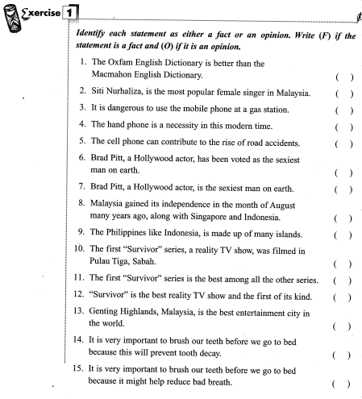

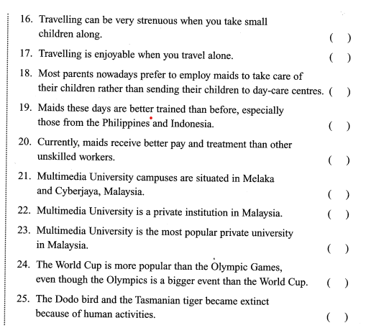

1. Opinion | 2. Opinion | 3. Fact | 4. Opinion | 5. Opinion
6. Fact | 7. Opinion | 8. Fact | 9. Fact | 10. Fact
11. Opinion | 12. Opinion | 13. Opinion | 14. Fact | 15. Fact
16. Opinion | 17. Opinion | 18. Opinion | 19. Opinion | 20. Opinion
21. Fact | 22. Fact | 23. Opinion | 24. Opinion | 25. Fact

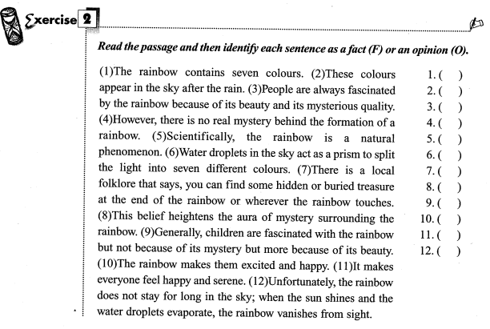
1. Fact | 2. Fact | 3. Opinion | 4. Opinion
5. Fact | 6. Fact | 7. Opinion | 8. Opinion
9. Opinion | 10. Opinion | 11. Opinion | 12. Fact

